**Aaron Williams**

**Assignment 1**

**17 May 2017**

**Problem 1:**

Create a program that uses the escape sequence \ “ to print your favorite quote.

Output:

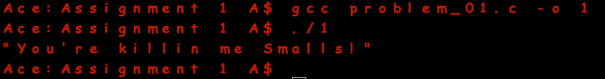

**Problem 2:**

Create a program that uses escape sequence \\ to print the following directory structure: c:\cygwin\home\administrator.

Output:

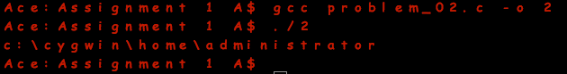

**Problem 3:**

Write a program that prints a diamond, as shown here:

*

* *

* *

* *

* *

* *

*

Output:

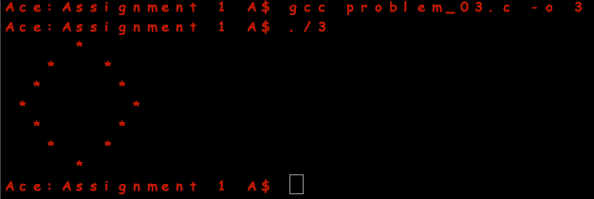

**Problem 4:**

Given a = 5, b = 1, x = 10, and y = 5, create a program that outputs the result of the formula f = (a – b)(x – y) using a single printf() function.

Output:

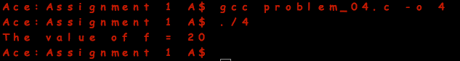

**Problem 5:**

Create a program that uses the preceding formula and displays the result, but this time, prompt the user for the values a, b, x, and y. Use appropriate variable names and naming conventions.

Output:

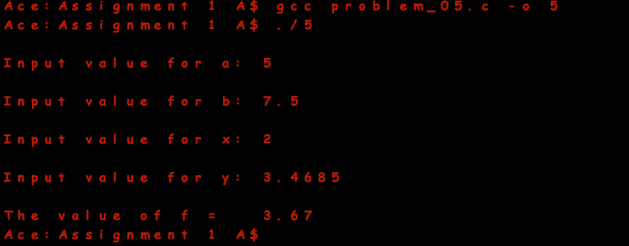

**Problem 6:**

Build a Shop Commission program that prompts a user for data and determines the commission for a merchant selling gear using the following formula: Commission = Rate * (Sales Price – Cost).

Output:

